I ran into a snag while doing this lab...
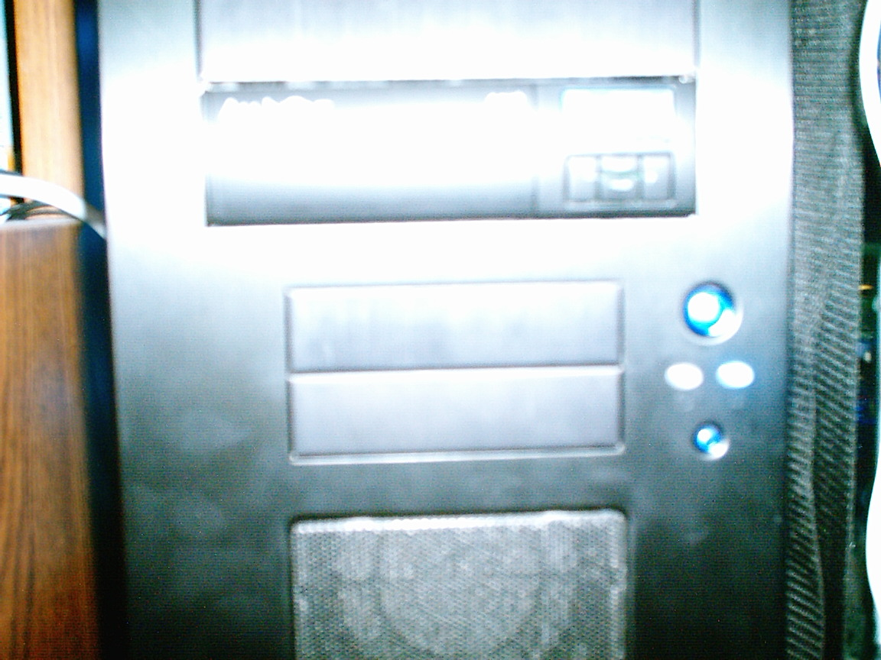
...I don't have a floppy drive! I watched Carl do this lab though, and this afternoon in CIS, we used a program called GWSCAN to wipe hard drives. A big box of hard drives. I'm talking, like, thirty hard drives. So I think I'm correctly experienced with doing a secure wipe of a disk. I don't really have any good way to prove this to you though. But the biggest snag I can think of is that I don't have a floppy drive. I did have one, but it came from my first PC with a 3.5” disk drive, and it finally died last year. I also haven't used a floppy disk in about 4 years, so I don't really miss it.

